REPLY OF PRESS CLIPPING PUBLISHED IN DIFFERENT NEWSPAPER
Newspaper Date / Writer | Comments of Writer | Reply of PBS | Remarks of Committee Members
The Dawn  13-09-2017  Nosheen H. Anwar | - Political Parties, Communities groups and civil societies including demographers have all voiced concerns about the partial results. Misgivings stem from concerns about the handling and compilation of data in Islamabad rather than at the provincial level as was previously done.  - Additionally, dynamics like displacement and migrations from KP to large cities (especially Karachi) in migrations to Urban Sindh, Horizontal Population moment and consequent densification of cities have hardly surfaced in the partial results. When Sindh’s growth rate is less than that of Balochistan and KP, it raises concerns about how the Census was undertaken. If Sindh’s Urbanization level are deliberately under stated, it will have grave, long term consequences for planning and governance to mitigate climate change. | Pakistan Bureau of Statistics (PBS) conducted the Census-2017 in free fair, and transparent manner throughout the country with the assistance of Armed Forces. It is worth mentioning that data collected by the enumerators of provincial governments who are either teachers, local governments staff or Revenue Staff and the data collected by them in summary sheets was used to prepare provisional results of census-2017. Further the same summary sheets were scanned and presented to Technical Committee along with the data entered in database for giving confidence that the data as received at the ground has been entered in database and same is used in compilation of provisional results. As regard compilation of data in Islamabad rather than at provincial level, it was decided that for timely, credible data provisions and for safety and security of the census material the whole data compilation and processing be carried out at the headquarters because all the necessary equipment, human resource and proper space for handling the gigantic task of compilation of data of two hundred million individuals was available at Headquarters.  It is informed that the same methodology for data collection is adopted all over the country and the concerns, that Sindh population is deliberately understated is unfounded. For collection of data in general population De-Jure method used as done in 1998. In De-jure method people are counted at their usual place of residence and time period of residence was defined as 6 months and above. The homeless population was counted using the De-Facto method. In this case persons are counted where they are found (residing) during the time of census. All persons living in a particular census block (enumeration area) were counted whether they had a CNIC or not (or no identification at all). As the Census is about counting all population living within geographical boundaries of the country whether they are Pakistani or not. Sindh growth rate almost remain same however, the main increase in growth rate of KP and Balochistan is due to major fact that Afghan Population who were previously not counted alongwith general population in 1998 Census (as they were confined in the camps) have been allowed to settle in other areas and counted along with the general population. Further there is huge increase in Karachi population of almost 6.2 million peoples i.e. despite the fact that fertility rates are continuously falling especially in big cities.
Daily Express  12-09-2017  Sahbeer Ahmed Arman | - The Writer stated that 1998 Census was rejected by political concerns, as Census-2017 provisional results also by same concerns rejected by political parties. Last Census was conducted in the country in 1998.  - In Pakistan census was not conducted in time i.e., ten years and Census -2017 was conducted after a span of 19 years. | Due to the linkage of census data with representation at the National / Provincial Assemblies and resources allocation the whole census process become politicized. However, it is pertinent to mention here that Census results are accepted by the majority with the exception of Province of Sindh. Further no stakeholder has till to date provided any tangible evidence in writing to Pakistan Bureau of Statistics. PBS come to know about their concerns through press, talk shows and press conferences. It is worth mentioning here that PBS has presented the true picture regarding the authenticity and quality of data with evidences at almost all forums for confidence building of stakeholders, the same was also presented to Cabinet Committee of Ministers constituted for devising recommendations of final results of Census-2017. However, there is always room for improvements and this can be deliberated in detail before conducting of next census.  The 6th Population & Housing Census was due in 2008. The Government decided in April, 2006 to hold the 6th Population and Housing Census in October, 2008 with the assistance of Armed Forces. Accordingly, PBS initiated necessary steps to ensure timely conduct of Census. In this regard PBS completed all the work for conducting the Census in-time but could not be materialized due to law & order situation in the country, paucity of staff and financial constraints at that time.  In 2010, the Government approved the conduct of House Listing Operation in March / April, 2011 and Population and Housing Census in August / September, 2011. CCI also decided that assistance of Army Personnel will be required for conducting the above operation, availability of Armed Forces personnel during that period may also be checked / ensured. In compliance to the CCI’s decision the department held meetings with the Secretaries, M/o Defence and Interior. The Secretaries assured availability of security personnel wherever requisitioned by the civil authorities under ‘in aid of civil administration’ but not at man to man level as requested. House Listing Operation was done without the assistance of Armed Forces. However, the results of HLO-2011 was scrapped by the CCI due to abnormal figures which are not demographically possible. Thereafter, again process was stopped, CCI in Feb. 2016 decided to conduct Census after availability of Armed Forces. Accordingly, after availability of Armed Forces, Census was conducted in 2017. Hence, delay in conducting the Census was not on the part of PBS.
The Dawn  11-09-2017  Bureau Report | - Leaders of various political parties have rejected the result of census in Khyber Pakhtunkhwa and federally administered tribal areas and asked the federal government to Rectify the mistake in census otherwise they would start protest demonstrations over the issue. Pakistan people party provincial president Mohammad Humayun Khan said in a statement the process of census had become controversial from day one when the relevant staff started writing down the data on plain papers with pencils. Qaumi watan party chairman Aftab Ahmed khan Sherpao also rejected the interim census report to FATA. | Pakistan Bureau of Statistics (PBS) conducted the Census-2017 in free fair, and transparent manner throughout the country with the assistance of Armed Forces and support of the provincial governments through provision of their staff for data collection and monitoring. It is pertinent to mention here that Census results are accepted by the majority with the exception of Province of Sindh. Further no stakeholder has till to date have provided any tangible evidence in writing to Pakistan Bureau of Statistics. PBS come to know only through press, talk shows and press conferences. Even PBS have presented the facts regarding the points raised in media and other forums and presented the true picture. Initially at start of Census operation in March some complains were received regarding entering of information with pencil but immediately action was taken and directions were issued to all concerned to refrain for this practice.
Business Recorder  09-08-2017  M.A.Zuberi | - The first basic question relates to the census methodology. There are two approaches to census enumeration. The first is the de-jure approach in which persons are counted at their usual place of residence. The second is the de-facto approach, in which persons are counted where they are found on the census data. The 1998 Census applied both the approaches simultaneously during enumeration. However, the data was tabulated and published on de-jure basis for comparability with the previous censuses.  - The second question relates to the definition of urban area the approach adopted is based on the list of urban areas by the provincial governments. As such the areas covered by metropolitan corporations, municipal corporations, municipal committees, and town committees and cantonments are treated as urban. However, it may have led to some understatement of the size of urban population.  - The explanatory notes to the 2017 census estimates should clarify the definitions of household and place of usual residence. Also given the large number of afghan refugees and TDPs, where they are located in the census is of some important. | It is clarified that enumeration of general population in both censuses were done using de-jure approach. In the De-Jure method people are counted at their usual place of residence and time period of residence was defined as 6 months and above. It is worth mentioning that de-facto approach is used for only homeless population in both censuses. In de-facto approach persons are counted where they are found (residing) during the census.  PBS do not have their own definition of Urban/Rural areas, PBS strictly follows the Urban Rural boundaries as notified by the Revenue and Local Government Authorities. Accordingly, Urban areas are those areas which are notified by the Revenue Authorities / Local Governments of the respective Provincial Governments and Directorate General of Military land & Cantonment. Urban areas are comprised of Metropolitan Corporations, Municipal Corporations, Municipal Committee, Town Committees and Cantonments. Therefore, there may be areas which have urban characteristics but not counted as urban as they are not notified as urban area.  Agreed, the definition of household & usual place of residence must be mentioned alongwith the results, however, PBS continuously explained these definitions through media, and during dissemination of results. It is also informed that the whole census methodology alongwith all basic definitions will be part of the report of final results census- 2017. The matter regarding shifting of TDPs population from the area of their residence to respective Agencies was discussed in a Consultative meeting which was held on 12.05.2018 (Minutes of the meeting Annex-1). However, as census enumeration was based on De-Jure approach according to which the population should be enumerated in the areas where they were residing at the time of census operation. Therefore, the Experts did not agree with the proposal as it was against the adopted census methodology. After detail deliberations, it was decided that the TDPs population may be counted in the areas where they were residing at the time of census operation and may not be shifted to their respective Agencies as it may create inconvenience / problems.
The Dawn  19-09-2017  Fahim Zaman | - According to an official conducting census in Karachi, many people unable to produce CNICs were not only dropped from the count but some were even detained by law enforcement agencies. In some parts of the city, army enumerators, while filling their “Form-786” were asking questions that were not even printed on their forms. These included questions about ethnicity, sectarian identity (Shia, Sunni) and arms licenses. According to him, a protest was even lodged with the authorities suggesting that such questions were scaring away people and resulting in poor public participation in the census. These details were also confirmed by a senior PBS official. On Aug, 28 Chief Census Commissioner, Habib Ullah Khattak claimed on private channel that PBS had only 6.5m CNICs verified by NADRA from the data collected. The question is: why would PBS even need to have CNICs verified when the possession of CNICs was not a precondition for being counted?  - Chief Statistician PBS Asif Bajwa stated before a Senate Standing Committee that PBS, in collecting the provisional results shifted data for people found living for less than six months back to their place of permanent residence. How could PBS know the period of an individual’s stay at a given place when the question pertaining to internal migration was not part of questionnaires used for enumeration? The information about internal migration will be collected through Form 2A as par to the 7.5 pc sample survey if that actually takes place.  - According to a Statistics Division insider, the provisional results tabulated on the basis of the heads counted through REN-Forms (Census block summaries) initially projected a population of 2.6m for Kohistan district. However, the district had registered a population of merely 472,570 in 1998. While KP’s average household size of over seven persons remains the largest in the country, someone at PBS appeared to have realized that a 550-pc increase wouldn’t fly with anyone; therefore, the numbers were adjusted to 784,711 similar to those for nearby Shangla.  - Probably to make the impending census transparent, the finance minister during a pre-census meeting of the governing council constituted as special committee of eminent demographers and non-government members of the council. At least three members of that committee claimed while speaking to Dawn that none of their recommendations were addressed.  - The Statistics Division has already spent over Rs. 26 billion (About & 260m) on the ongoing census even while using ruthlessly truncated 1998 forms for housing and population censuses (Form-1 and Form-2). | Data of all households were collected even if CNIC was available or not. Condition of CNIC was not mandatory. All persons living in a particular census block (enumeration area) were counted whether they had a CNIC or not (or no identification at all). The perception that people who don’t have CNIC were not counted is incorrect as the Census is about counting all population living within geographical boundaries of the country whether they are Pakistani or not. It is very important to mention here that the CNIC number of the head of household in random and specific cases were checked against NADRA record to verify the data. This method was only used as a deterrent so that people should not over-report households’ member’s numbers as these numbers are linked with resource allocation, representation and other important characteristics so that reliable and credible data may be provided for informed decision making / planning. The perception that individual data was shared with NADRA is incorrect, only CNIC number was sent in random cases. According to records, out of the 207.8 million people living at the time of census in the country, the CNIC of only 6.5 million people have been verified. While army personnel only directed to note down the numbers of the people living in the household in their form 786 while listening to the enumerator interviewing the household member. PBS did not receive any complaint regarding asking to sect / armed licence questions. further PBS had clearly defined the role of Army and Civil Enumerators in their manual of instructions and training imparted separately to the civil enumerators and Army Personnel for Census operation-2017.  It is clarified that Chief Statistician / PBS had never given statement regarding shifting of people data who are living less than 6 months back to their permanent place of residence regarding general population, as it is not possible in any case to determine the period of living at the headquarters in compilation of provisional results. The information ascertaining the period of stay at the particular place is only possible at the time of enumeration while interviewing the respondent. So it not factually correct that PBS has use this practice. However, it is worth mentioning here that at the time of census significant portion of areas of erstwhile FATA were displaced due to ongoing operation in those areas. Therefore, to address the concerns of relevant people of that areas it was decided before the census that M/o SAFRON will provide the list of the TDPs to adjust them back into their areas. But later on, the decision of the experts and members of the Technical Committee constituted for census-2017 the adjustment has not been incorporated for TDPs because it is contrary to the methodology adopted for Census I.e. De-Jure where the person is counted at the place where they residing for more than 6 months.  It is correct that at the time of compilation of the provisional results of Census-2017, abnormal increase in population / growth rate was observed while processing the census data pertaining to Kohistan district. Consequently, PBS realized and brought this into notice of Technical Committee of the Governing Council of PBS constituted for Census-2017 in its 9th Meeting held on 7th July, 2017 and the matter was discussed in detailed. After detailed deliberations on the recommendations of Technical Committee / Sub-committee of Governing Council, it was decided to adjust the population of Kohistan according to the nearby districts or growth rate of the province after checking by all dimensions for estimating a reliable figure which depicts the actual ground reality. This shows that PBS was already working efficiently and checking the data prudently to note any abnormal reporting of population and adjust it accordingly.  Most of the recommendations of the Technical Committee were implemented such as:  Recommendation Implementation  The PBS will ensure during the training that individuals are counted at their usual place of residence. PBS implemented this recommendation  The reference period or cut off for migrants on de-jure household members who have been away from home as a cut off for inclusion is last six months. The committee recommends rewording of last six months to “since Eid ul Azha last” which corresponds with September 2016 i.e. six months before the Census. Correction were made in the page #9 of Manual of instructions for Form-2, same were circulated to all the respective officers on 17.02.2017.  The recording of the CNIC of the head of a household at the end of form-2 should be optional. All household should be included in the census and later if the information is required bifurcated by those HH with IDs or not. Data of all household were collected even if CNIC was available or not. Condition of CNIC was not mandatory.  In no case should the CNIC number be sent for checking because it will delay the census and detract from its validity and uniformity altogether. Only 6.5 million ID cards were randomly verified through NADRA. This was done only for the deterrence purpose and to increase the credibility of results.  Inclusion to three more religion groups i.e. Sikhs, Parsis & Bahai in the question 6 about religion. It was not possible at that stage because census forms were already printed in 2008 and process of training already completed. If these recommendations were incorporated, then the data would have become under reported.  The Census Forms were prepared and finalized by the Census Advisory Committee in the year 2007-08, which were later approved by the Cabinet. There were 42.5 million ICR forms initially got printed through financial support of UNFPA from UK based DRS Firm by spending US$ 1.35 million. The Sub-committee of the Governing Council was formed on 31st January, 2017 and in its follow-up meetings, the committee had suggested change in questionnaire. The compliance of the committee was not possible due to lengthy and time-consuming process. The Printing of specially designed ICR Forms require longer time as well as heavy financial cost. It was not possible for PBS to discard a huge quantity of Forms and get revised Forms reprinted in short time with heavy burden on Government’s exchequer. Due to above reasons High Courts and Supreme Court were apprised with the situation and Honourable, Courts allowed to use same printed forms and directed to include code in Gender question to cover disability. However, it proved not helpful as field work has already started and instructions sent by headquarters could not able to reach each corner.
The Dawn  17-10-2017  Methab S. Karim | - The provisional results of the much-delayed census in Pakistan are shrouded in mystery and ambiguity due to lack of transparency. the 2017 census recorded a total population count of 207.8 million with an annual growth rate of 2.4 pc during 1998-2017.  - Surprisingly the growth rate in Sindh the destination for millions of migrants from other provinces is at per with national average. Meanwhile growth rates of 3.41 pc in Baluchistan and 2.8pc in Khyber Pakhtunkhwa are not on the higher side due to the inclusion of Afghan refugees who have intermingled with local population there, unlike in Sindh particularly in Karachi where they along with other migrants remain isolated and thus perhaps have not been counted. However, Punjab annual growth rate of 2.13 pc is mainly due to reduced fertility and migration within and outside the country.  - Counting in census is never perfect and usually some people are left out. The validity of a census results is universally accepted procedure of post Enumerations survey (PES) which is conducted in randomly selected areas following a census, and its cross checked with the census results of the same areas. A PES is routinely conducted in countries, with varying results. In Pakistan a PES was conducted following the 1961 census, which indicated an undercount of 6.7pc and consequently the population was adjusted upwards. The PES results after the 1981 census was not released, whereas the exercise was not carried out after the 1998 census, nor is one planned following the 2017 census. | PBS tried its best for conducting the census in the designated year i.e. 2008 however, it was delayed due some unavoidable circumstance including provision of budget, law & order situation and availability of Armed Forces. PBS ensured the conduct of census in most transparent way by involving all the provincial governments for collection and monitoring of data collection process, constitution of vigilance and monitoring teams comprising of the provincial government representatives for provision of credible, authentic and as confidence building measure among all relevant stakeholders. Further a Sub-Committee of the Governing Council comprising of all eminent Demographers and Experts was constituted by the government for seeing / monitoring the whole Census process. Moreover, for sake of the confidence building of the provinces regarding the compilation of census results Provincial Technical Committees were constituted. These committees visited PBS and were briefed regarding the whole census process, compilation process and tabulation of results they were also given detail presentation showing the scanned summary forms sent by the staff of provincial governments alongwith data entered in database for increasing their trust and confidence regarding data compilation. It is also worth mentioning that control room were established at Headquarters and all provincial offices of PBS for addresses the grievances of the people and for complete coverage. As per provisional results of Census-2017, the total population of Pakistan is 207,774 million with an average annual growth rate 2.40% over period of 1998-2017. The Provisional results show as overall increase in population by 57% over the year 1998, while the population increased by 146.6% since Census 1981.  It is clarified that there is a decline in the population growth rate at national level. According to provisional result of Census-2017 a nominal increase in percentage share of Population has been observed in the Sindh Province with 23.05% in 2017 as compared to 23.00% in 1998. However, there is decline in percentage share of population of Punjab from 55.63% to 52.95%. According to 1998 Census the total population of Karachi Division was 9,856,318 as compared to provisional results of Census-2017 where the total population of Karachi Division is 16,051,521. It is pertinent to mention here that the annual growth rate of Karachi 1998 to provisional results of 2017 increased to 2.60 percent and the Percentage change is 62.86%. Further the growth rate of Sindh Province is equivalent to National growth rate of 2.40%.  It is clarified that impression that Afghani’s and other migrants are not counted during population and housing census-2017 in Karachi is factually incorrect. PBS has adopted the same methodology all over Pakistan for counting of population and covered all persons living in the particular block / area whether they are nationals or aliens. Further PBS had divided the whole country into 168,944 blocks which cover all the areas having population and accordingly all the blocks were covered for complete coverage.  It is fact that PES is an effective tool to assess the under / over coverage of population in the census process, but in Pakistan PES survey was not conducted for 1998-Census as well as in Census-2017 with the reason that both the Censuses were conducted under the supervision of Armed Forces by deploying Army Personnel with Civilian Enumerators at man to man level which served as deterrence and ensured transparency/credibility in the process. Both the operations were considered to be most supervised, therefore, the need to conduct PES after Census Operation was not felt. Moreover, same methodology / environment is required to conduct PES which means that availability of requisite number of Army Personnel alongwith logistic arrangements to replicate the same process, which practically was not possible. There are number of countries which do not conduct PES or even do not adjust population figures after conducting of PES. Armed Forces had developed their own Form called 786, for collection of household information. This practice was also adopted in 1998 Census.
The Dawn,  4th July, 2018  The Dawn  19-09-2017  Fahim Siddique  DAWN  04.01.2021  Dr. Zeba A. Sathar | - There has been much controversy around the Census-2017. Indeed, when the 24th constitutional amendment bill which would let the ECP use the provisional results for delimitation of Electoral constituencies was presented in the Senate, the opposition refuse to support it without certain conditions being met. These included a third-party validation survey of 5% of randomly selected census blocks, supervised by a census commission comprised of reputed demographers, the final report of which would be 30 days. Any deviation of the sample survey results with the provisional census figures beyond plus-minus one percent would be incorporated in the final Census results.  - The reason why the PBS readily accepted this view was because of technical evaluation of the 6th Population Census prepared by an expert committee. The committee finding are revealing, for example report notes that the Governing Council of the PBS had constituted a sub-committee to advise the PBS. But the sub-committee took the view that the Census was not being planned the way it was envisaged and none of its recommendations were being followed in true and sprit.  - Furthermore, it found that Geography / GIS officer had not been involved in the process of updation work of both urban and rural area frame and maps, that there was a lack of coordination among national bodies and that poor compliance on the recommendation of national and international agencies, coupled with an acute shortage of technical expertise and staff, “had left the PBS with a number of loopholes”.  - A pilot census was not undertaken despite being strongly and repeated recommended by the national and international experts. The sub-committee also believed that, given that there is never an error free census and owning to a lack of comprehensive and accurate data from other sources such as civil registration and population registers, a post enumeration survey (as is the practice in many countries) was needed.  - In the run up to the census the Baloch were especially agitated about the inclusion of afghan refugees holding computerized national identity cards in Balochistan’s population, fearing that a million Afghans could fall in that category. If counted as pakhtuns, they would reduce the baloch to a minorities in own province. The Balochistan chief minister and most baloch politicians have been tight-lipped about the veracity of the census-they are probably waiting for the final verdict. As an example one can cite insurgency struck Kech (Turbat) district where free movement of men and machine so less than 250 pc – up from 413,204 in 1998 census to 909,116 today. has become vastly restricted due to the perilous security situation, yet the enumerators were apparently able to the count a total population increase of no less than 250 pc – up from 413,204 in 1998 census to 909,116 today.  Firstly, the next census must truly include all residing persons whether or not they have CNICs their full numbers and relevant information that ensure their rights under constitution in order to reach this goal the Govt. and PBS must first recall clearly the main reason why census is held around the world every ten years. It is not for political reasons but to services and resources and ensure rights just based on the correct count of every who lives in a territory.  Secondly, the census has to be conducted in a way that increase the peoples trust in the government. This trust has been shaken and must be rebuilt, given how the previous census was viewed as enabling the advancement of political goals rather than the people’s rights and privileges.  Third, the army’s role must be clarified. Ostensibly, Armed Personnel accompanied enumerators in both the last censuses (1998 to 2017) due to security concerns they were only expected to perform the role of escorts and onlookers, ensuring the enumerators’ security. However, they became directly involved in the data collection, beyond their original mandate, sometimes even recording data. The UN put this on record as a violation of international census protocol in a letter to the government.  Fourth, the census must use modern technology, including the recording of information through handheld devices, correlating to GPS coordinates, to ensure transparency of responses. We must stop relying on archaic indelible ink, paper, and sluggish methods for transporting reams of data across the country in order to save months of processing time. The provinces should be able to maintain their own counts rather than reply on a central data base so that database can be shared to avoid administrative delays.  Finally, can the census data (about to be released) be utilized to convince the gurus tasked with fixing Pakistan’s economic problems of the criticality of demographic trends for planning the economy? | - CCI in its meeting held on 13.11.2017 & 24.11.2017 decided to conduct 5% Validation Exercise by third party while approving the block wise results for publication.  - Accordingly, PBS undertaken following implementation / processing steps; bids were invited through open advertisement in national newspapers from leading Firms / Joint Ventures registered with Government / FBR)  - PBS Consultant Selection Committee (CSC) shortlisted Twelve (12) Firms / Joint Ventures. After scrutiny, PBS proposed detailed TORs and RFPs to be considered in the 15th PBS Governing Council meeting fixed on 16th February, 2018.  - Meanwhile Senator Taj Haider conveyed 9-points agreement signed by Parliamentary Parties Leaders after consultative meeting held under the Chair of Prime Minister recommending constitution of a 3-Members Census Commission of reputed Demographers after mutual consultation which was to act as 3rd party to conduct validation exercise.  - Relevantly mentioned, Prime Minister’s Office did not convey the 9-Point agreement, neither it is formally referred by Parliament. However, a Census Commission consisting of three demographers was also notified.  - Senator Taj Haider expressed objections on methodology as well as the composition of the Census Commission. He further raised multiple issues/queries, asserting that 9-Points based agreement earlier settled with Prime Minister has to be followed without any modification. Meanwhile, he also moved an Adjournment Motion in Senate impugning Validation Exercise which he considered was not in line with what the Parliamentary Parties Leaders agreed.  - Therefore, the meeting o the Governing Council of PBS which was scheduled to consider and finalize the methodology for validation of census and TORs of third party for 5% validation was postponed on the direction of the Chairman Senate.  - Chairman Senate directed PBS to pend the meeting of PBS Governing Council till such time as Leader of the House in Senate convenes a meeting and some result comes form that meeting.  - PBS accordingly requested Leader of the House in Senate for meeting to settle the issue. The Leader of the House has fixed the meeting, however, no decision was made and resultantly the process of validation was halted.  It is further submitted that during 6th Population and Housing Census-2017, the Army Personnel were also deployed in field operation along with Civilian enumerators. The Army personal and the civil enumerator matched / cross check the data on daily basis. Since the proposed methodology for PES was not comparable with the census methodology and non-availability of Armed Forces therefore, the whole process could not proceed.  Most of the recommendations of the Technical Committee were implemented such as:  Recommendation Implementation  The PBS will ensure during the training that individuals are counted at their usual place of residence. PBS implemented this recommendation  The reference period or cut off for migrants on de-jure household members who have been away from home as a cut off for inclusion is last six months. The committee recommends rewording of last six months to “since Eid ul Azha last” which corresponds with September 2016 i.e. six months before the Census. Correction were made in the page #9 of Manual of instructions for Form-2, same were circulated to all the respective officers on 17.02.2017  The recording of the CNIC of the head of a household at the end of form-2 should be optional. All household should be included in the census and later if the information is required bifurcated by those HH with IDs or not. Data of all household were collected even if CNIC was available or not. Condition of CNIC was not mandatory.  In no case should the CNIC number be sent for checking because it will delay the census and detract from its validity and uniformity altogether. Only 6.5 million ID cards were randomly verified through NADRA. This was done only for the deterrence purpose and to increase the credibility of results.  Inclusion to three more religion groups i.e. Sikhs, Parsis & Bahai in the question 6 about religion. It was not possible at that stage because census forms were already printed in 2008 and process of training already completed and not possible to include at this stage. It is worth mentioning here that on orders of Supreme Court disabilities codes were added in the questionnaire by communicated the instructions through media and by letter to all enumerators on 15th March, 2017, however as it was not part of questionnaire & no comprehensive training regarding the matter was imparted. This is the reason that adding instructions in already printed questionnaire was not feasible and therefore not incorporated as its results are counter-intuitive.  Observation given is not based on facts. It is clarified that Officers/Officials of Geography/ GIS Wing were fully involved in the process of updation and digitization of urban area maps. However, due to shortage of Geography staff, Statistical Assistants (SA) of defunct FBS were involved in updation of rural area frame. Teams comprising of one Geography staff and one SA were formed to complete the assignment in team approach. Staff of Geography Wing was responsible for taking of GPS coordinates and other points of interests (POIs) while SA was responsible for preparation of sketch map of blocks alongwith recording of Quick Count Records (QCR) information.  A pilot Census was carried out at the planning stage in all over the country during 2008 for conduct of 6th Population and Housing Census. Detail report in this regard was prepared and lessons learnt through pilot census were utilized in the planning process.  PBS had also conducted a test run at limited scale in the vicinity of Islamabad and Rawalpindi areas during November - December, 2016 to check the material purchased for Census use, the respondent’s behavior on filling up of questionnaires and time required to complete a census block. However, it could not be replicated at large scale due to the reason that Supreme Court of Pakistan had passed orders on 16th December, 2016 to start field operations from 15th March, 2017, hence no time was left for conducting Pilot Census. Agreed that no census is perfect there are always chances of omission / errors and under reporting / over reporting. However, PBS tried their best to provide credible and reliable results.  According to UN-Convention all persons living in a country in a specified time will be counted irrespective of their nationality or any legal status, if a person does not have a CNIC even then he has been counted. As regard the issue regarding Kech and Awaran districts, it is informed that census in Kech and Awaran was conducted during two phases due to less number of local lavies / police staff available for census duty. However, PBS had made all efforts to conduct the census in Kech and Awaran correctly / transparently using the same census methodology as was done throughout the country and also extended the time of field operation for complete coverage. Regarding the issue pertaining to Afghanis all Aliens including Afghanis living within the geographical boundaries of Pakistan were counted in the enumeration process. However, it is pertinent to mention here that during the 1998 census the Afghanis were confined in Camps, and the enumeration process was not carried-out in camps, so census results did not include their numbers as they were treated as refugees. This is one of the reasons for the increase in population of KP and Balochistan in Census 2017. After 2005, these camps were converted to refugee villages and people were allowed to move and settle out of the camps for live with the local population. For Census 2017, the data of any existing refugee villages was taken from the village’s administration.  Data of all households were collected even if CNIC was available or not. Condition of CNIC was not mandatory. All persons living in a particular census block (enumeration area) were counted whether they had a CNIC or not (or no identification at all). During the Census-2017 only 6.5 million ID Cards were randomly verified through NADRA. This was done only for the deterrence purpose and to increase the credibility of results. Conducting the Census after ten years is international practice. In Pakistan, first four Censuses i.e. 1951, 1961, 1972 and 1981 were held on time while Census 1998 & Census-2017 were delayed due to security reasons as well as unavoidable circumstances. However, PBS will follow the suggestion in upcoming Census.  PBS has conducted all the previous censuses in free, fair and transparent manner which were acceptable to all stakeholders. However, efforts will be made to further enhance the trust of people in the upcoming Census.  Suggestion regarding clarification of Army’s Role in the Census will be reviewed for the next census.  PBS is already planning to conduct the next census on tablet based and will use modern techniques to further ensure transparency and credibility of Census data.  As mentioned earlier the efforts will be made to consider the suggestion in the next census regarding the use of modern technologies to further enhance the transparency of responses.
Karachi’s Population Issue
The news  11-09-2017  Zaigham Khan | - The MQM party is angry that Karachi population has not properly counted in the “rigged” census. Karachi city population can’t be less than thirty million while it has been counted at 40.9 million. | The Lahore – Karachi Population issue  The table of census results of 10 big cities in Pakistan has generated debate, and especially why the growth rate of Lahore is higher than Karachi. It was observed, while analyzing the Lahore –Karachi population figures, that some of the critics have expressed their views on this sensitive matter without going to the background of the question considering essential factual points. The figures of Lahore and Karachi City are, as below: -  Cities Population Census 1998 Population Census 2017 Growth Rate Percentage Change  Karachi 9,339,023 14,910,352 2.49 59.66  Lahore 5,143,495 11,126,285 4.14 116.32  A cursory look at this table has raised many queries but to analyze it, one has to see what happened actually between 1998 and 2017; period during which Lahore’s Population has doubled. As mentioned before, PBS does not define urban and rural areas and goes by the notified areas (definition) given to them by Local Governments Revenue Departments of each respective Province: accordingly, these numbers are actually representing the areas notified as urban and rural by the respective Provinces. Punjab Government in January 2015 declared the whole Lahore District as Urbanized and, in fact, two Union Councils Babliana Utar & Bucho Ke Majah of District Kasur were also added in Lahore District, therefore now there is no rural part in Lahore and Lahore City is actually Lahore District. To understand it with facts, let’s see the below mentioned table to capture the true & complete picture, compared with census 1998. The Population in census 2017 of same area of Lahore which was urban in 1998 are as below: -  Lahore Population 1998 Population 2017 Growth Rate Percentage Change  City as defined in 1998 5,143,495 8,123,193 2.43 57.93  The above table shows that if we compare the population of the similar area in 1998 and 2017, as it was defined as urban in 1998, the growth rate and percentage change, both are less than Karachi. The huge increase in Lahore Population is due to extension of boundaries of Municipal Corporation and declaring rural areas as urban in 2015. Clear picture of situation can be seen by analyzing the population growth of areas which were in Lahore City in 1998 with the same area in 2017 so that apple to apple comparison can be made.  The below table will further help to solve the puzzle:  LAHORE CITY DISTRICT Population 1998 Population 2017 Growth Rate Percentage Change  Urban (as per 1998) 5,143,495 8,123,193 2.43 57.93  Rural (as per 1998) 1,196,619 2,956,106 4.9 147.03  Sub total 6,340,114 11,079,299 2.98 74.75  Two UCs of Kasur added 21,369 46,986 4.23 119.88  Total 6,361,483 11,126,285 2.98 74.90  KARACHI DIVISION  Urban (as per 1998) 9,448,808 14,910,352 2.49 57.80  Rural (as per 1998) 407,510 1,141,169 5.56 180.03  Total 9,856,318 16,051,521 2.60 62.86  It is therefore obvious from the above table that the Lahore city population has seen considerable (increase of 5,982,790 during 1998 to 2017 among this increase almost 2,982,790 is actually due to inclusion of rural areas and two union council of Kasur District) increase in population due to inclusion of rural areas in city limits. Furthermore, these rural areas which are declared urban now, have higher growth rates as most of the new settlements are now developing in these areas. Contrary to the Karachi city alone has seen increase of 6.2 million populations in these 19 years among which only 0.6 million is due to inclusion of rural areas of Karachi division. This is further clarified in the form of maps placed at (Annex-2). This phenomenon has also been observed in Islamabad where the rural population has shown huge growth as shown below:  Islamabad Population 1998 Population 2017 Growth Rate Percentage Change  Urban 529,180 1,014,825 3.48 91.77  Rural 276,055 991,747 6.95 259.26  Islamabad District 805,235 2,006,572 4.91 149.19  The above tables of Lahore and Islamabad have clearly depicted the situation that cities are now growing in peri-urban areas, and, in the case of Lahore, the inclusion of these areas in Lahore Municipal Corporation has led to higher population size in Lahore city: hence, there is no abnormal phenomenon behind it. If the Boundaries of Karachi city had also been extended by the respective Provincial Government, similar type of increase would have been observed in Karachi City Population.
Akhbar-E-Jehan  11-09-2017  Qasir Mehmood | - During the Census-2017 no step have been taken for controlling the illegal practice’s as was done in past. further the Sindh’s government and other political parties have rejected the census results of urban and rural areas of Sindh’s.
The Dawn  10-11-217  Shahid Saeed | - The largest complaint is coming from the Muttahida Qaumi Movement (MQM), which had complained of undercounting in Karachi in 1998 as well. There are three major issues that need to be understood. First, the 1998 census figures for Karachi and Lahore need to be understood properly. Second, The demarcation of urban and rural areas is important and ignored by many who are complaining. Third, there is a major issue with exaggerated estimates clouding judgment about the provincial census results.
- It is not surprising that the decisional population count, a constitutional obligation was delayed by almost two decades and was held only on the intervention of the apex court. Not surprisingly the provisional results of latest census too are being disputed.

- There are some questions regarding the methodology used and how the urban and rural divide is defined. it is Sindh that is set up in arms over what is described by its governments as a deliberate attempt to understate the population of the province. The facts that Karachi’s population is less then what estimates showed gives some credence to Sindh’s objections. Meanwhile the population of Lahore has more than doubled in the same period of time, causing some eyebrows to be raised.
The Dawn  19-09-2017  Fahim Siddique  The Dawn  19-09-2017  Iftikhar A.Khan | - According to provisional results the figures, 75,584,989 people live in 12,192,314, households in the country’s urban areas. This translates into an average household size of 6.19 persons. Let us start by examining the released figures for Karachi and Lahore as parallel datasets are readily available for them. These will also serve to demonstrate the anomalies and errors in the current exercise.  - According to an official conducting census in Karachi, many people unable to produce CNICs were not only from the count but some are even detained by law enforcement agencies.  - According, to a Statistics Division insider, the provisional results tabulated on the basis of the heads counted through REN Forms (Census block summaries) initially projected a population of 2.6m for Kohistan district. However, the district had registered a population of merely 472,570 in 1998.  - PBS did not even heed the recommendations made by the UNFPA-that not only supported the census by contributing $12m but also provided much needed technical support- to conduct pre-pilots and post-census sample verifications. According to eminent demographer, Dr. Mehtab Karim, post –Census verifications should be conducted immediately after the census to avoid anomalies in samples due to internal migration.  - In census 2017 the population of Karachi becomes half while the population of Karachi is not less than 3 cores. Similarly, the population of Sindh’s was shows 33% i.e. 1 core and 49 lacs, consequently the census of Karachi is not acceptable.  - For the purposes of the census however, declaring all of Lahore as ‘Urban” would mean clubbing the rural and urban populations together, but that alone could not have doubled Lahore’s population from 6.3m to 11.1 m over the last 19 years.  - The population of Karachi has been shown to be less than that of Lahore – a palpable nonsense. This is explained by fact that the Punjab government had in 2015 notified boundaries in Lahore plus two of the union councils of Kasur, whilst the boundaries of Karachi for electoral purposes have remained as they were in 1998.with annual growth rate of Karachi being lower in 1998.with annual growth rate of Karachi being lower then Lahore and the projections of the international observer’s group being close to the declared provisional results much is perhaps explained. If this is indeed the case then the discrepancy is understood but it is not an argument easily accepted hence the meeting on 13-11-2017. Much of the onus now rests on the shoulder of the Election Commission of Pakistan ECP. There is a window of three to four weeks at most, behind which electoral slippage looms.  - The opposition in the senate rejected provincial census as flawed, raising questions over authenticity of the exercise which showed population of Lahore more than that of Karachi. Pakistan people’s party alimentary leader in the senate in the senate Taj Haider said that a survey showed the population of Karachi at 24.7 million, while the provisional results showed it at 14.7 million. Terming the provincial results inaccurate, he said people from across the country came to Karachi for employment and it was the largest abode of Pashtuns. Saeed ul Hassan Mandokhel of the PML Qaid said the people of Baluchistan had also rejected the census as it was manipulative. He said Punjab was the only province where population increased.

Annex-1
No. 1(2)/2004-PBS (Coord)
Government of Pakistan
Statistics Division
Pakistan Bureau of Statistics
*******

Subject: MINUTES OF THE CONSULTATIVE MEETING OF EXPERTS TO DISCUSS FINAL RESULTS OF CENSUS-2017.

A Consultative meeting of Experts, Senior Officers of Statistics Division/ Pakistan Bureau of Statistics and Consultant on census from UNFPA to discuss the Final Results of Census-2017 before presentation to the CCI was held on 12th May, 2018 at 11:00 AM under the Chairperson of Secretary, Statistics Division in the Conference Room of Statistics House, Islamabad. The list of participants is attached.

2. Meeting started with the recitation of versus from Holy Quran. Chair welcomed the participants and informed that PBS has compiled the Final Results of Census-2017. This meeting has been convened to discuss the final results and to have suggestions from the Experts for improvement of the National Census Report as per recommendation of the Experts to make it as per international standards. The Final Results of Census-2017 will be presented before the Council Common of Interests (CCI) in its meeting to be held on 14th May, 2018 for approval. The participants thanked the Chair for inviting them for this consultative session and sharing the final census results with them before submission to the CCI. Chair asked the Member (C&S) to give presentation to the house.

3. The Member (C&S) presented the proposed tables on key indicators to be incorporated in the National Census Report, 2017. The main indicators presented in the meeting included total population, sex ratio, population density, rural / urban distribution, average annual growth rates, provincial shares, population distribution by religion, mother tongue and literacy ratio etc.

- In addition to above, issues on Afghan Refugees living in Camps, blocked CNICs, Diplomats living in the country during census operation and adjustment of TDPs in their respective Agencies were discussed for decision to be taken by the house. The house was informed that no significant variation between provisional and final results of Census-2017 have been observed, which constitute a difference of 68,738 individuals with percentage variation as -0.033%. Prof. Dr. Nancy Stiegler, Consultant, UNFPA appreciated the quality of compilation of results in two stages i.e. provisional and final results by observing a negligible difference. While quoting international practices, she mentioned that generally observance of around 5% margin of errors is acceptable in the Census results worldwide.

- During the meeting the participants raised following observations and gave suggestions accordingly.

- In response to Dr. Zeba A. Sathar’s question relating to occurrence of similar differences at lower side in all of the provinces, Member (C&S) mentioned that in some districts positive differences were also observed, but these differences were balanced out at compilation stage and negative differences have been observed at Provincial and National level.

- Dr. G. M. Arif asked about the reasons for higher average household size and lager share of KP and Balochistan Provinces in the total population as compared to 1998-Census. Member (C&S) explained that the same was observed due to counting of Afghan Refugees living common population while in 1998, this segment of population was confined to Refugee Camps only. Regarding greater household size in these provinces, he agreed with results compiled and also quoted certain indicators such as total fertility rate, children ever born and average household sizes at National and Provincial level in support of the census results.

- Dr. Muhammad Iqbal enquired about the uniform occurrence of negative differences between provisional and final results with the remarks that whether it is due to estimation or any other reason. Member(C&S) explained the reasons as mentioned in the earlier para’s.

- Mr. G. M. Arif asked about difference of blocks observed in FATA and ICT Islamabad in the Provisional and Final Results. Mrs. Rabia Awan, Director explained that duplicate blocks were found in ICT and FATA which were corrected during compilation of final results, therefore, the change occurred in the provisional and final results. He also pointed out that the sex ratio of KP and FATA is on lower side. The Member(C&S) informed that due to working of male members of the household of KP and FATA in the middle east or other countries, such individuals have not been enumerated in the census process, therefore, the sex ratio is lower as compared to the other provinces. It was proposed that the population of KP and FATA need to be analyzed in the light of TDPs population.

- Dr. Minhaj ul Haq enquired about the counting of population of Afghan Refugees which have moved in settled areas of Punjab. The Member(C&S) explained the procedure of enumeration of Afghans Refugees living mixed up in common population as well as living in Camps.

- After detail discussion, following recommendations/decisions were made:-

i) Youth Population with Age Group

It was decided that youth population comprising of age group 15-24 years may also be added in the presentation as well as in the National Census Report.

ii) Urban / Rural Proportion

It was decided that Urban / Rural share in the total population may not be shown in the presentation, however, the same may be included in the National Census Report.

iii) Tables on distribution of Population by Mother Tongue and Religion

It was decided that the comparison of above table may not be made with the data of 1998-Census in the presentation. However, the same may be made part of the National Census Report.

iv) Single Year Age Pyramid

The house was informed that the age data reported in the census on single year age was not found consistent due to age heaping and digit preference. The Consultants from UNFPA suggested data smoothing through 3 years and 5 years moving averages techniques. The Consultants suggested that smoothed single year age data can be reported in the National and Provincial Census Reports, however, in case of District Census Reports (DCR) the age data may be represented in the form of 5 yeas age groups. The house agreed to the recommendation and decided to act upon accordingly.

v) Marital Status
It was decided that Table on Marital status table may not be shown in the presentation. However, it may be made part of the National Census Report.

vi) Literacy Ratio
It was observed that slide on the literacy ratio is two congested, hence the column of total population in the slide may be deleted and columns pertaining to literate population and literacy ratios may be retained in the slide. However, the same information may be retained in the National Census Report.

vii) Disability Data
The house observed that the data on disabled population collected during current census is not comparable with 1998-Census while the same is not up to the mark as compared with the data of 1998 Census. The Member(C&S) explained the reasons for under coverage of disabled population in the current census to the house. It was decided that disability data may not be shown in the presentation, however, it may be made part of the National Census Report highlighting the reasons of under coverage.

viii) Adjustment of TDPs Population in their Agencies of Origin
The house was informed that in the meeting held with the authorities of SAFRON, FATA Secretariat, FDMA and Political Leadership of FATA, it was decided that registered TDPs of three Agencies namely South Waziristan, North Waziristan and Orakzai Agency enumerated outside the above mentioned Agencies will be adjusted in the population of respective Agencies of their origin. Accordingly, a list of registered TDPs from FDMA has been obtained which was shared with NADRA authorities for verification of their CNICs and process of matching of this data with the census data base is in-hand. The population so matched will be shifted from outside Agencies to the respective Agencies.

The house objected on the process of shifting of TDPs with a view that according to the Dejure approach the population should be enumerated in the areas where they were residing at the time of census operation. Hence, shifting of such population from the area of their residence to respective Agencies is against the practice, therefore, the house is not in favor of this adjustment. After long debate, it was decided that the TDPs population may be counted in the areas where they were residing at the time of census operation and may not be shifted to their respective Agencies.

ix) Issues of Blocked CNICs Data, Afghan Refugees in Camps & Diplomats

The issues regarding shifting of population from Pakistanis to non-Pakistanis on the basis of blocked CNICs in the census data base exclusively on the basis of confirmed Aliens reported by NADRA authorities, inclusion of population of Afghan Refugees living in Camps and population of Diplomats residing in the country during census operation as provided by Ministry of Foreign Affairs were discussed in the house. The house was of the view that data of the above categories may not be included in the census results with the view that no demographic indicators are available regarding above categories.

7. Meeting ended with vote of thanks from the Chair.

*******

LIST OF PARTICIPANTS OF CONSULTATIVE MEETING OF EXPERTS TO DISCUSS FINAL RESULTS OF CENSUS-2017 HELD ON 12th MAY, 2018

- Ms. Rukhsana Yasmin, Secretary, Statistics Division, Islamabad
- Mr. Nasir Jamal, Senior Joint Secretary, Statistics Division, Islamabad
- Dr. Sajjad Akhtar, Chief Statistician, PBS, Islamabad
- Dr. Muhammad Iqbal, Member Governing Council
- Dr. Syed Muhammad Arif, Member Governing Council
- Dr. Zeba A. Sathar, Country Director, Population Council, Islamabad
- Dr. G.M. Arif, Member Governing Council
- Dr. Naushin Mehmood, Member Governing Council
- Prof. Dr. Nancy Stiegler, Consultant, UNFPA, Islamabad
- Dr. Minhajul Haq, Expert, Population Association of Pakistan
- Mr. Habib Ullah Khan, Member (C&S), PBS, Islamabad
- Mr. Muhammad Sarwar Gondal, Member (SS/RM), PBS, Islamabad
- Dr. Bahrawar Jan, Member (NA), PBS, Islamabad
- Mr. Khalid Hussain, DDG (Computer), PBS, Islamabad
- Mr. Muhammad Ashraf, Census Commissioner, PBS, Islamabad
- Mrs. Rabia Awan, Director, PBS, Islamabad
- Mr. Liaquat Ali Chattha, FMO(CP&C), PBS, Islamabad
- Mr. Inamullah Khan, ACC(CP&C), PBS, Islamabad
- Mr. Hazrat Khan, ACC(Table Verification), PBS, Islamabad
- Mr. Muhamamd Saleem, ACC(FO), PBS, Islamabad
- Mr. Saeed Ahmed, ACC(DP), PBS, Islamabad

*************

Annex-2
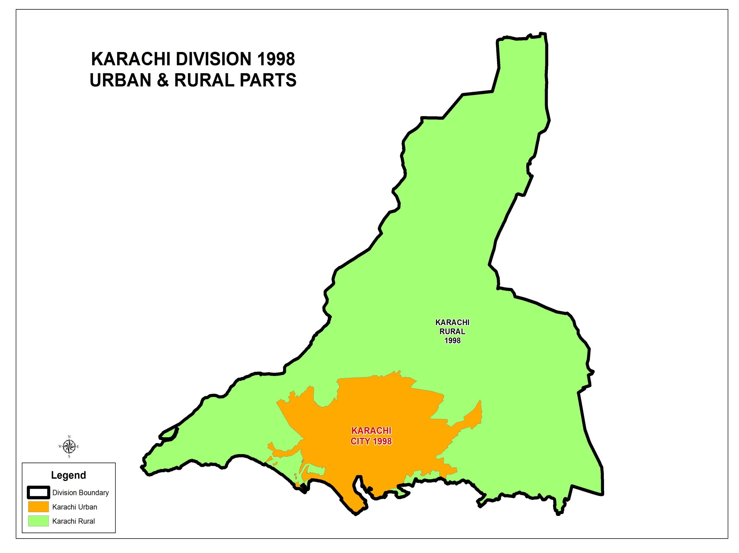
0.52 Million
9.339 Million

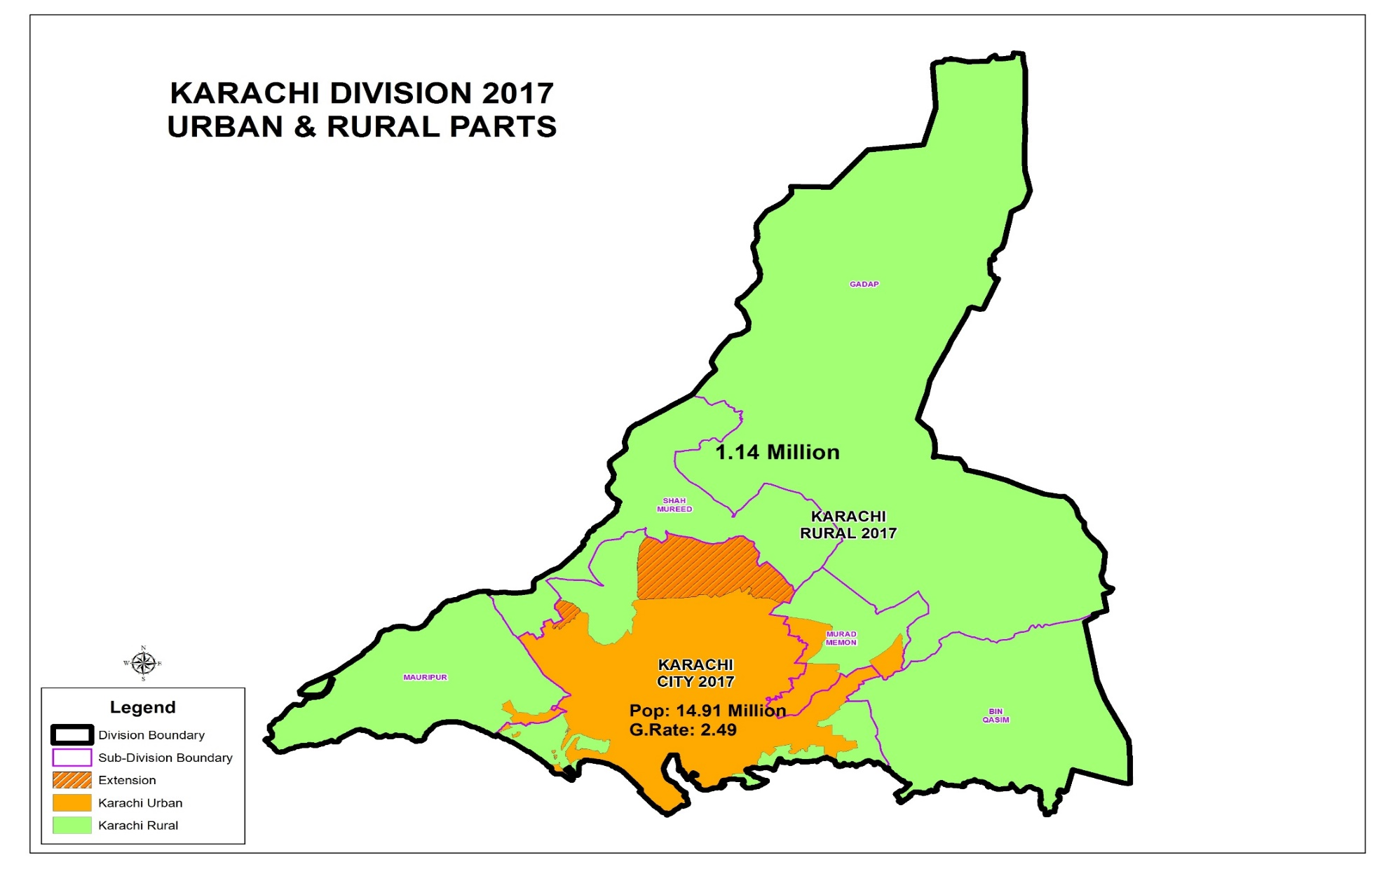
G.Rate:5.56
Pop: 598,446
G.Rate:9.50
Pop: 16,051,521
G.Rate:2.60

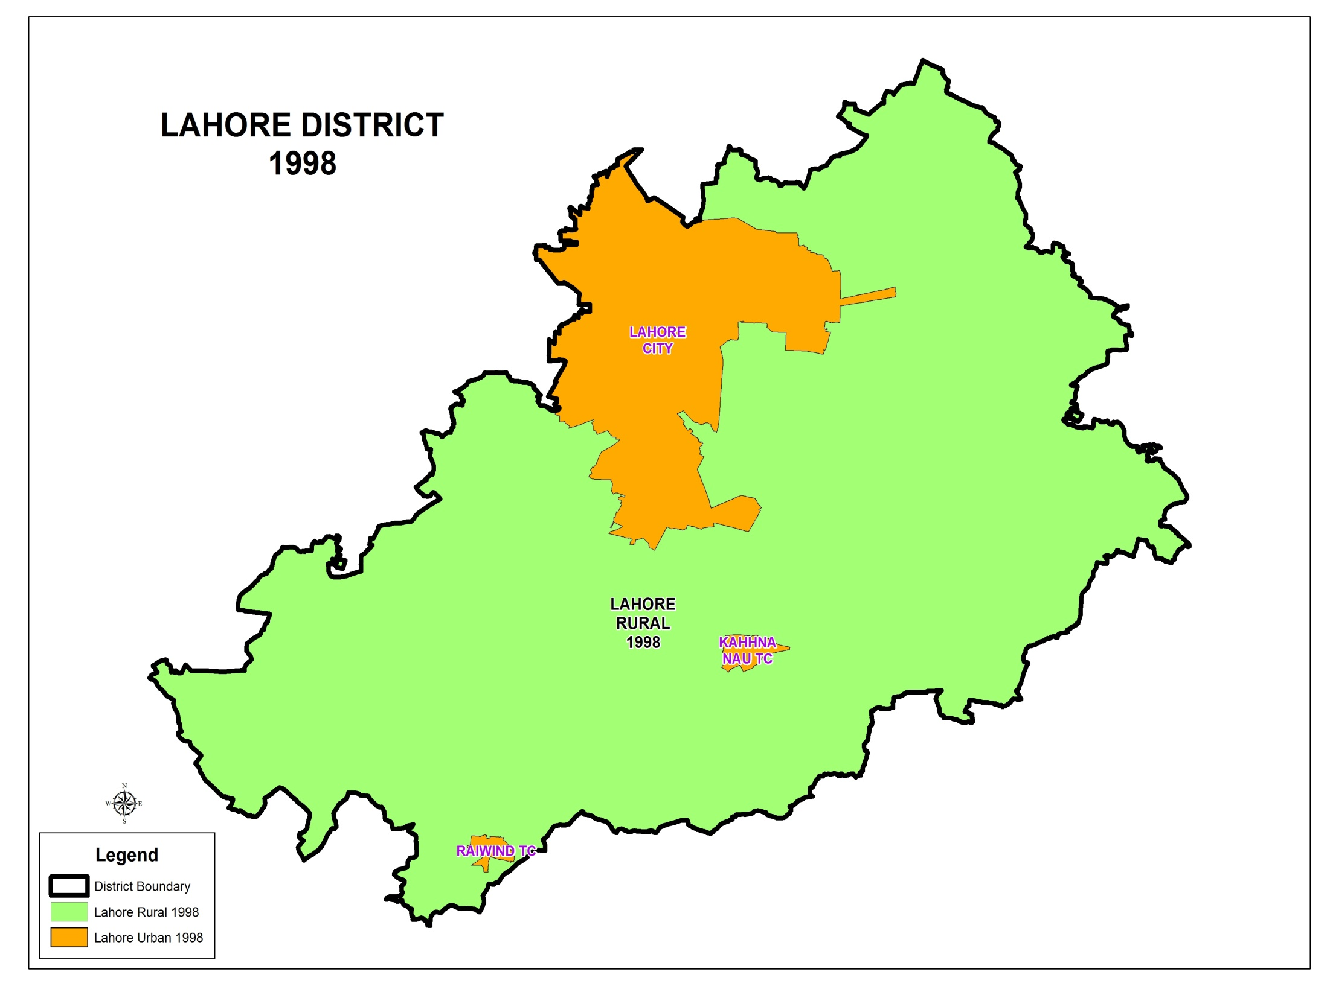
5,143,495
1,196,619
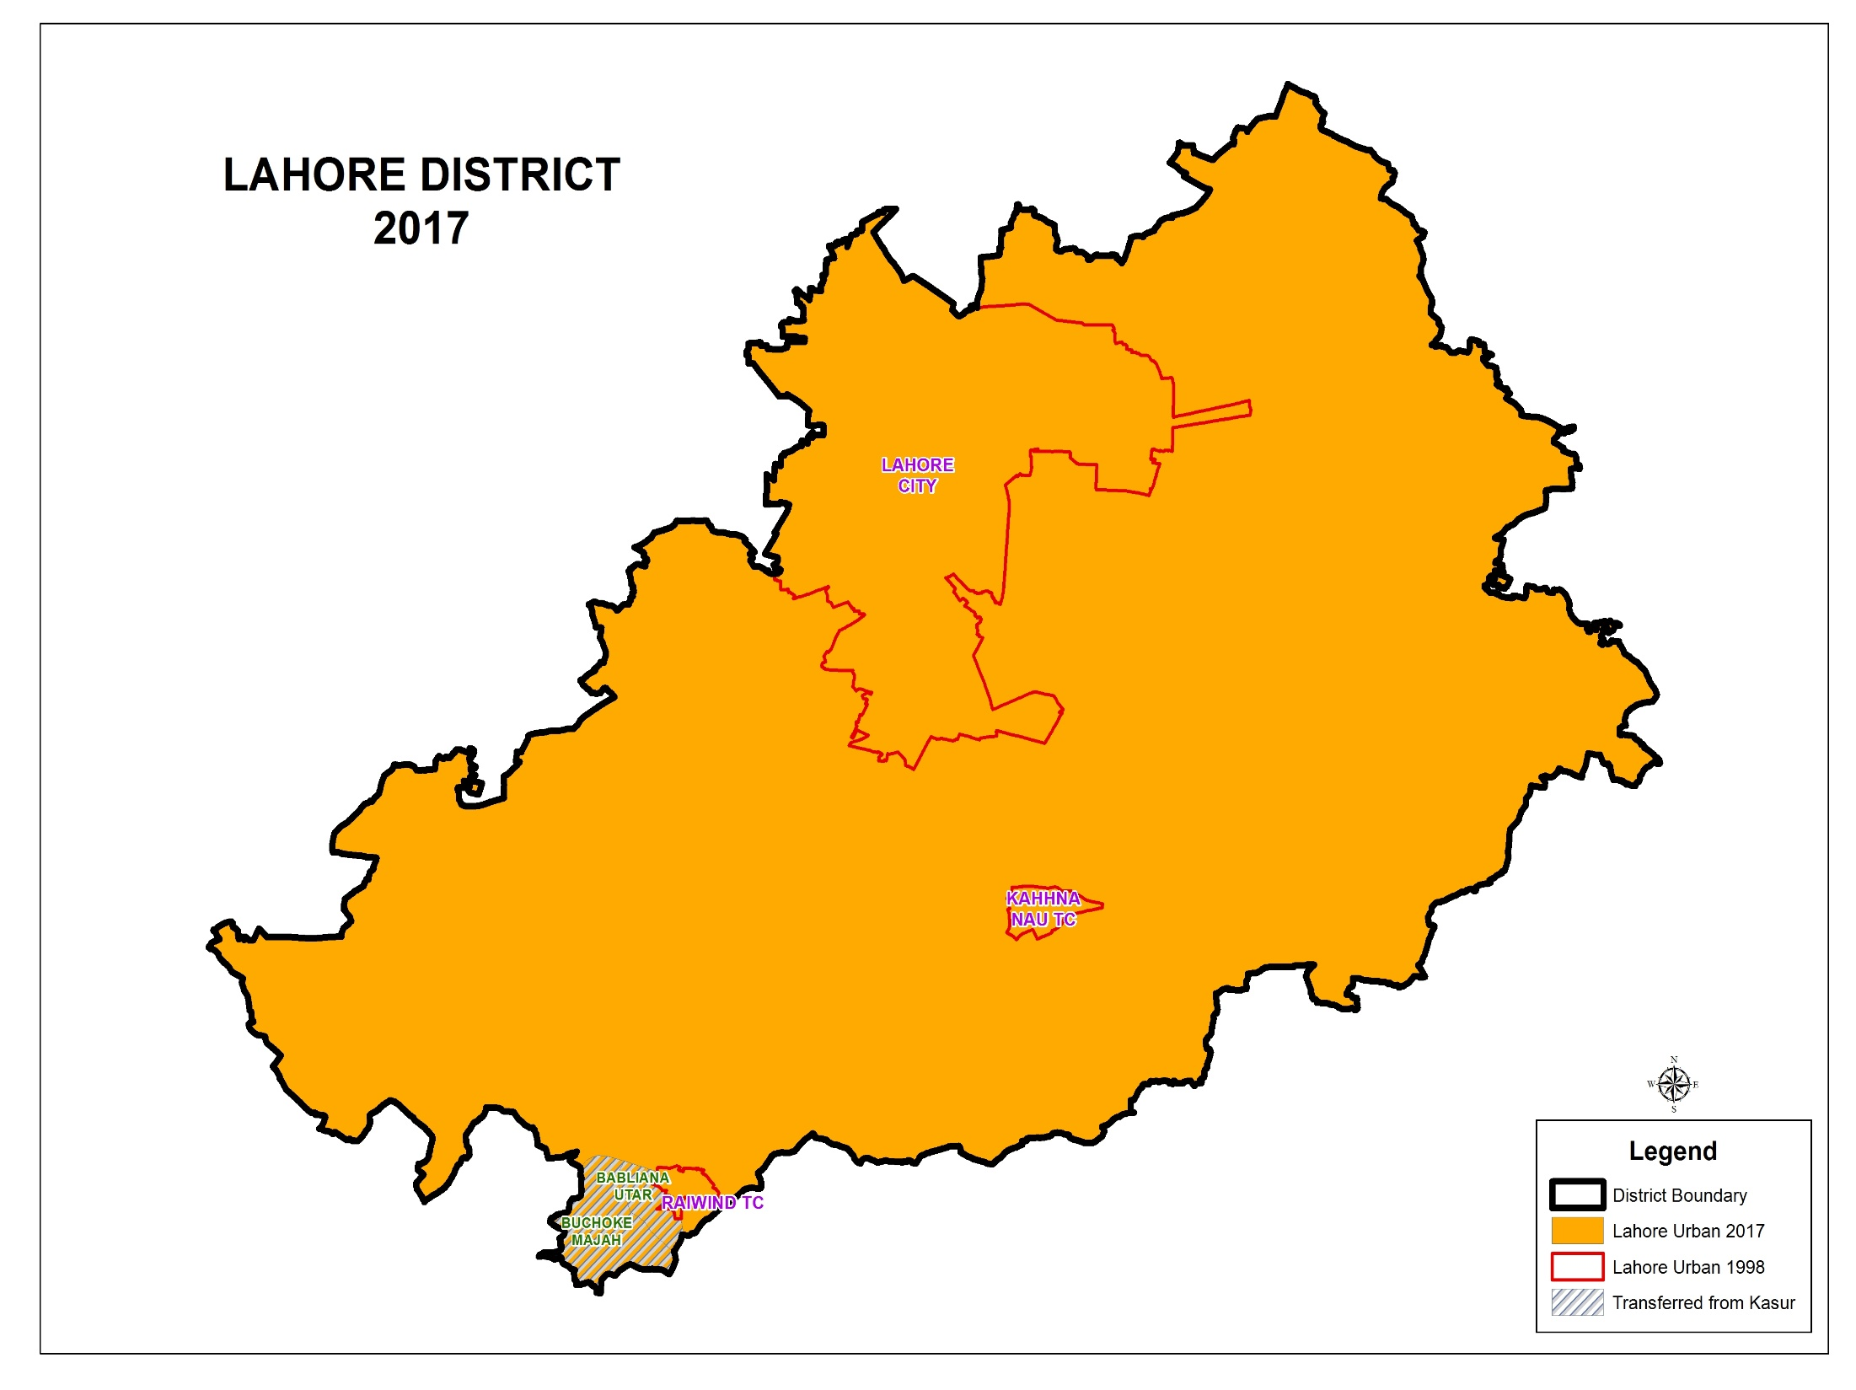
Pop: 2,956,106
G.Rate:4.9
Pop: 8,123,193
G.Rate:2.43
RURAL as Per 1998
Pop: 46,986
G.Rate:4.23
Lahore City /District Pop: 11,126,285
G.Rate:2.98
Voters : 4.94 million
CNIC Issued: 5.99 million

